Name : Uday Kumar
Branch and year : CSE 4 th year
AI related course work / project/ experience :
No practical experience but completed in collage course

Milestone 1: Dataset Collection and Preparation

WEEK-1 DAY-1

I have researched possible datasets that can be used in the project .
These datasets are different to each other. As per my findings Some of the data sets that can be use ful for this project are :

Sentinel-2 Surface Reflectance | COPERNICUS/S2_SR | ✔ Entire Globe | Ruins segmentation, NDVI, vegetation
Sentinel-1 SAR GRD | COPERNICUS/S1_GRD | ✔ Entire Globe | Buried structures, soil texture, radar
Landsat-8/9 Collection-2 L2 | LANDSAT/LC09/C02/T1_L2 | ✔ 180+ countries | Long-term erosion & history
Landsat-5 Archive | LANDSAT/LT05_L1TP | ✔ Historical global | Change detection (1984–2012)
MODIS NDVI (MOD13Q1) | MODIS/006/MOD13Q1 | ✔ Entire Globe | Vegetation monitoring
ESA WorldCover 2020 | ESA/WorldCover/v200 | ✔ Entire Globe | Land cover classification
SRTM DEM | USGS/SRTMGL1_003 | ✔ 60°N–56°S (almost world) | Elevation / slope / erosion
https://developers.google.com/earth-engine/datasets/catalog/COPERNICUS_S2_SR_HARMONIZED

https://developers.google.com/earth-engine/datasets/catalog/COPERNICUS_S1_GRD

https://developers.google.com/earth-engine/datasets/catalog/LANDSAT_LC08_C02_T1_L2

https://developers.google.com/earth-engine/datasets/catalog/MODIS_061_MOD13Q1

https://developers.google.com/earth-engine/datasets/catalog/CGIAR_SRTM90_V4

https://developers.google.com/earth-engine/datasets/catalog/FAO_GAUL_2015_level0

*** I also gone through (Copernicus Browser) which is helpful for download sentinel data but the size is too large for each.

https://browser.dataspace.copernicus.eu/?zoom=5&lat=50.16282&lng=20.78613&themeId=DEFAULT-THEME&visualizationUrl=U2FsdGVkX1%2BlVQyy6m%2BPCgBgmFgI5Ztu6irVGc37jphJpr5GbkX2lWIqscnnqRuGJ81a4VD82ONKZ9Ztw3GEfOc%2BAm5sH2kgv%2F48elKTp7Ae5Y3ShR08ZuMVoRQNDrPF&datasetId=S2_L2A_CDAS&demSource3D=%22MAPZEN%22&cloudCoverage=30&dateMode=SINGLE

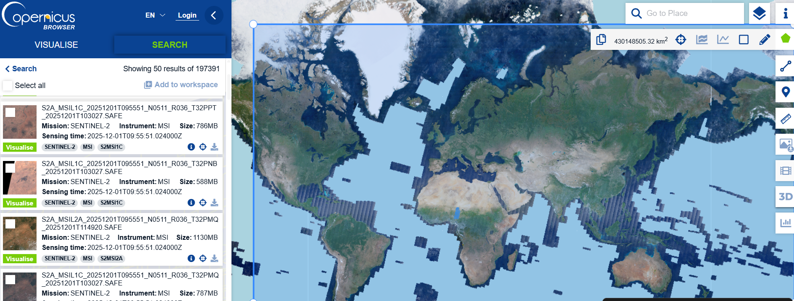

*** I also gone through (UNESCO Heritage Dataset)

The UNESCO World Heritage dataset provides:
Locations of globally recognized cultural & natural heritage sites
Site boundaries (polygons), coordinates, country, protection status
Site type (Cultural / Natural / Mixed)
Year of inscription and conservation state,
Description & significance of each site

I have also found (opentopography website) .. which provides High-Resolution Topography Data and Tools and also api’s and dataset downloads faster

OpenTopography - Medium Resolution Digital Elevation Model of Canada

https://portal.opentopography.org/dataCatalog?dataSources=global

Week1 day-2
I have understood about ruins and soil erosion

I have observed nasa earth data for data sets download and found

Harmonized Landsat and Sentinel-2 | NASA Earthdata

Week1 day-3

Segmentation of image (ruins, soil, artifacts, water)

